ARCHITECTURE - AEGIS FLARE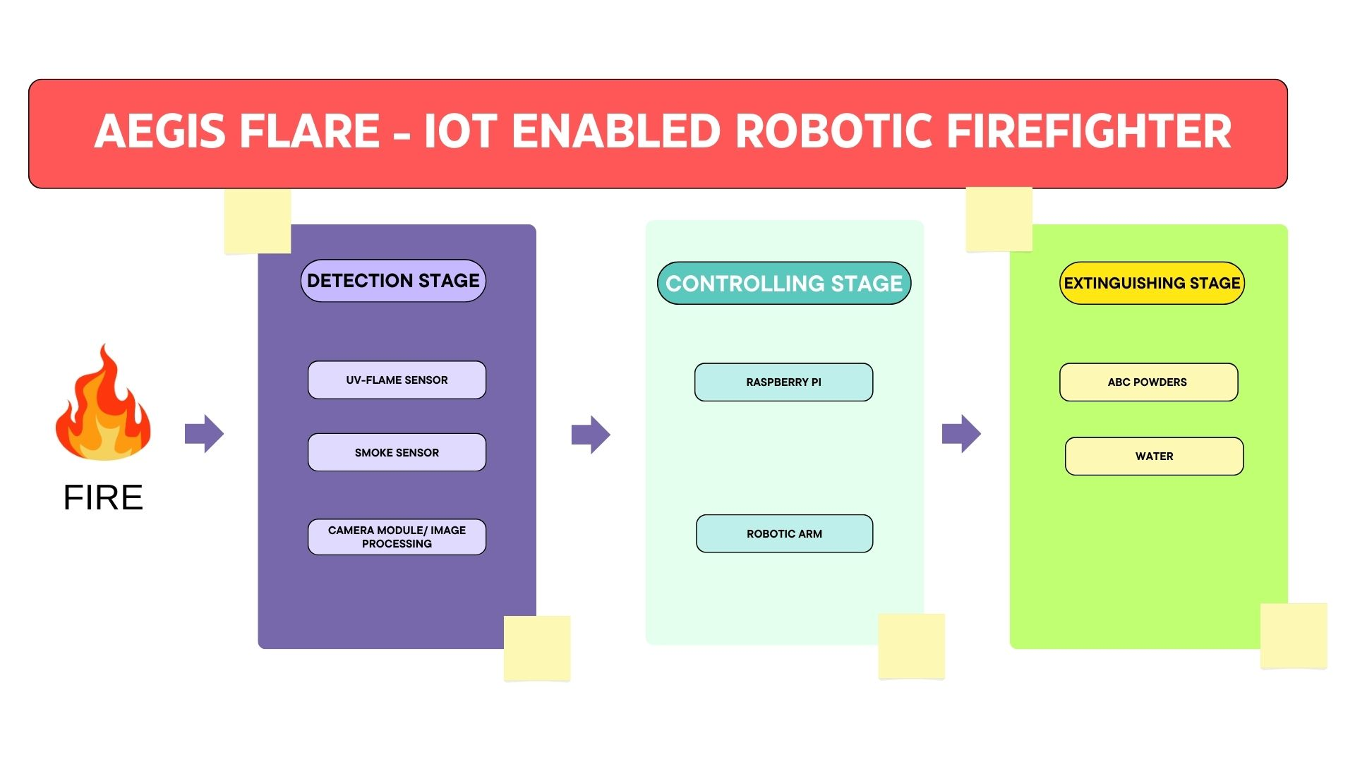

WORKFLOW – DIAGRAM

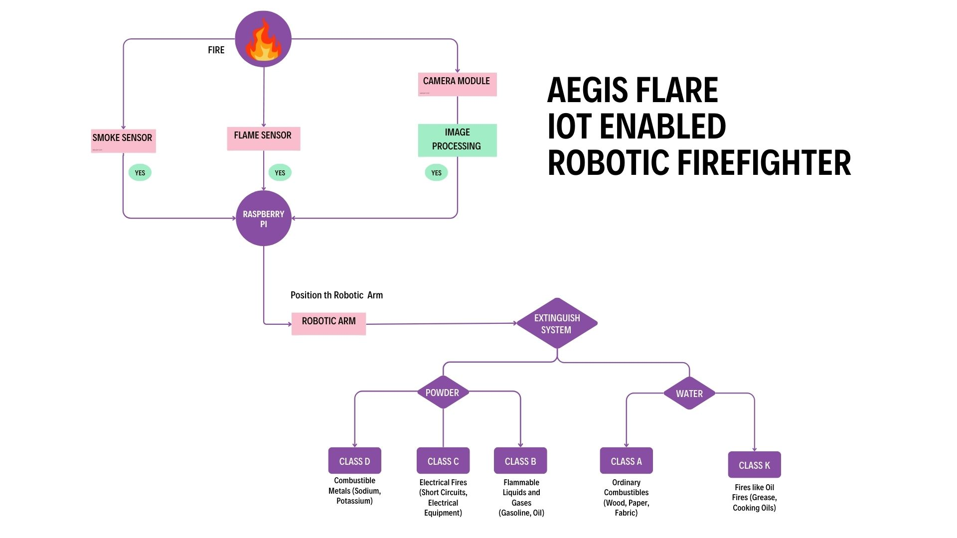

OUTPUT IMAGES

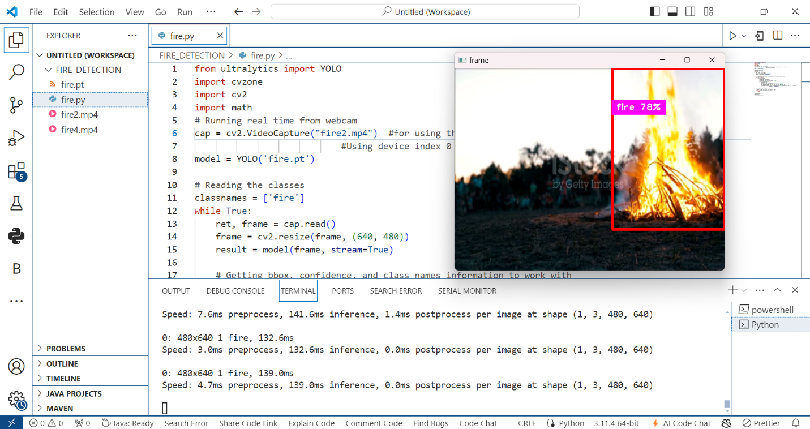

The Aegis Flare is an innovative IoT-enabled robotic firefighter that leverages advanced image-processing techniques to detect and respond to fire incidents in real-time. Utilizing OpenCV and YOLO for image recognition, this system efficiently identifies fire through video feed analysis, ensuring swift and accurate firefighting measures.

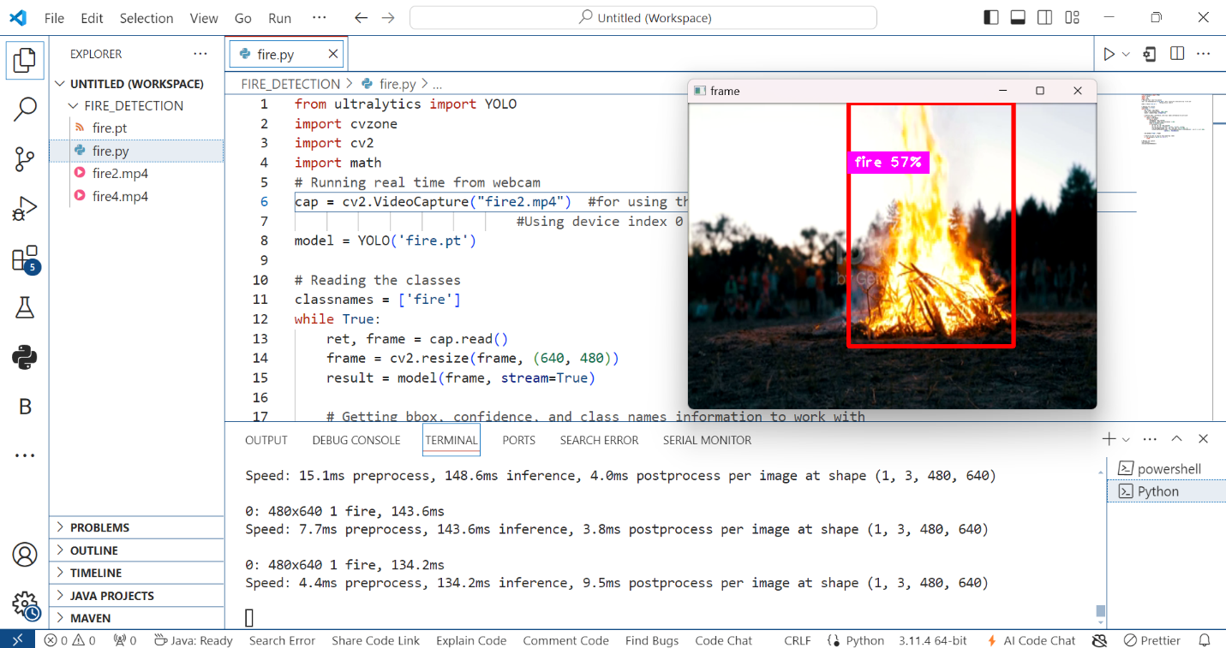

The system utilizes a Raspberry Pi as the central processor, connected to a camera module for video feed capture. Additional sensors, such as flame and smoke sensors, provide supplementary data for fire detection. Actuators control the robot's movement and firefighting mechanisms.

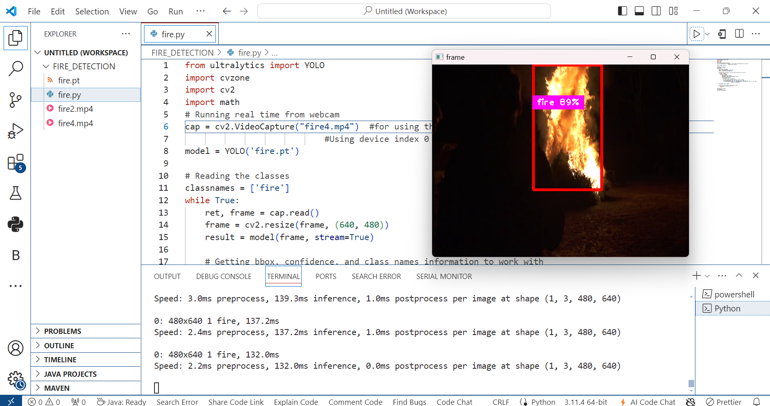

OpenCV is employed for image processing, enabling the system to analyze video frames for fire detection. YOLO (You Only Look Once) is used for object detection, providing high accuracy and speed in identifying fire. IoT integration allows for remote monitoring and control of the system.

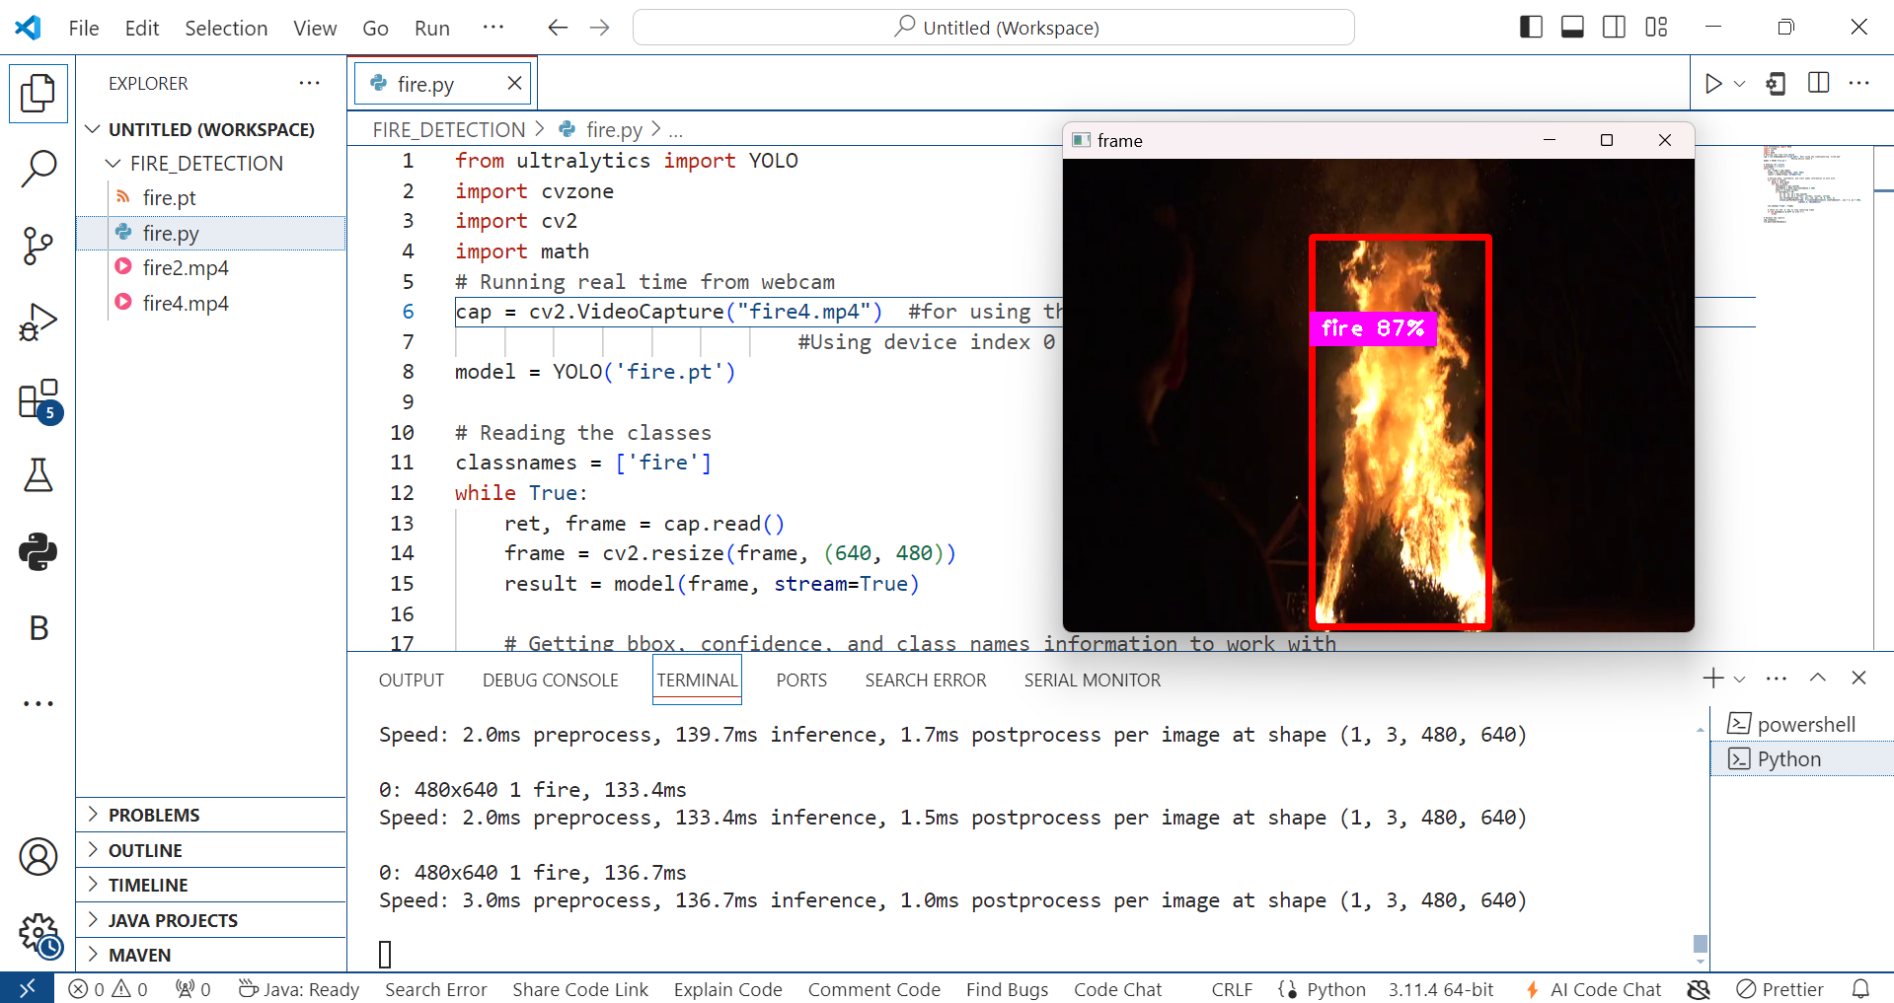

PROTOTYPE IMAGES

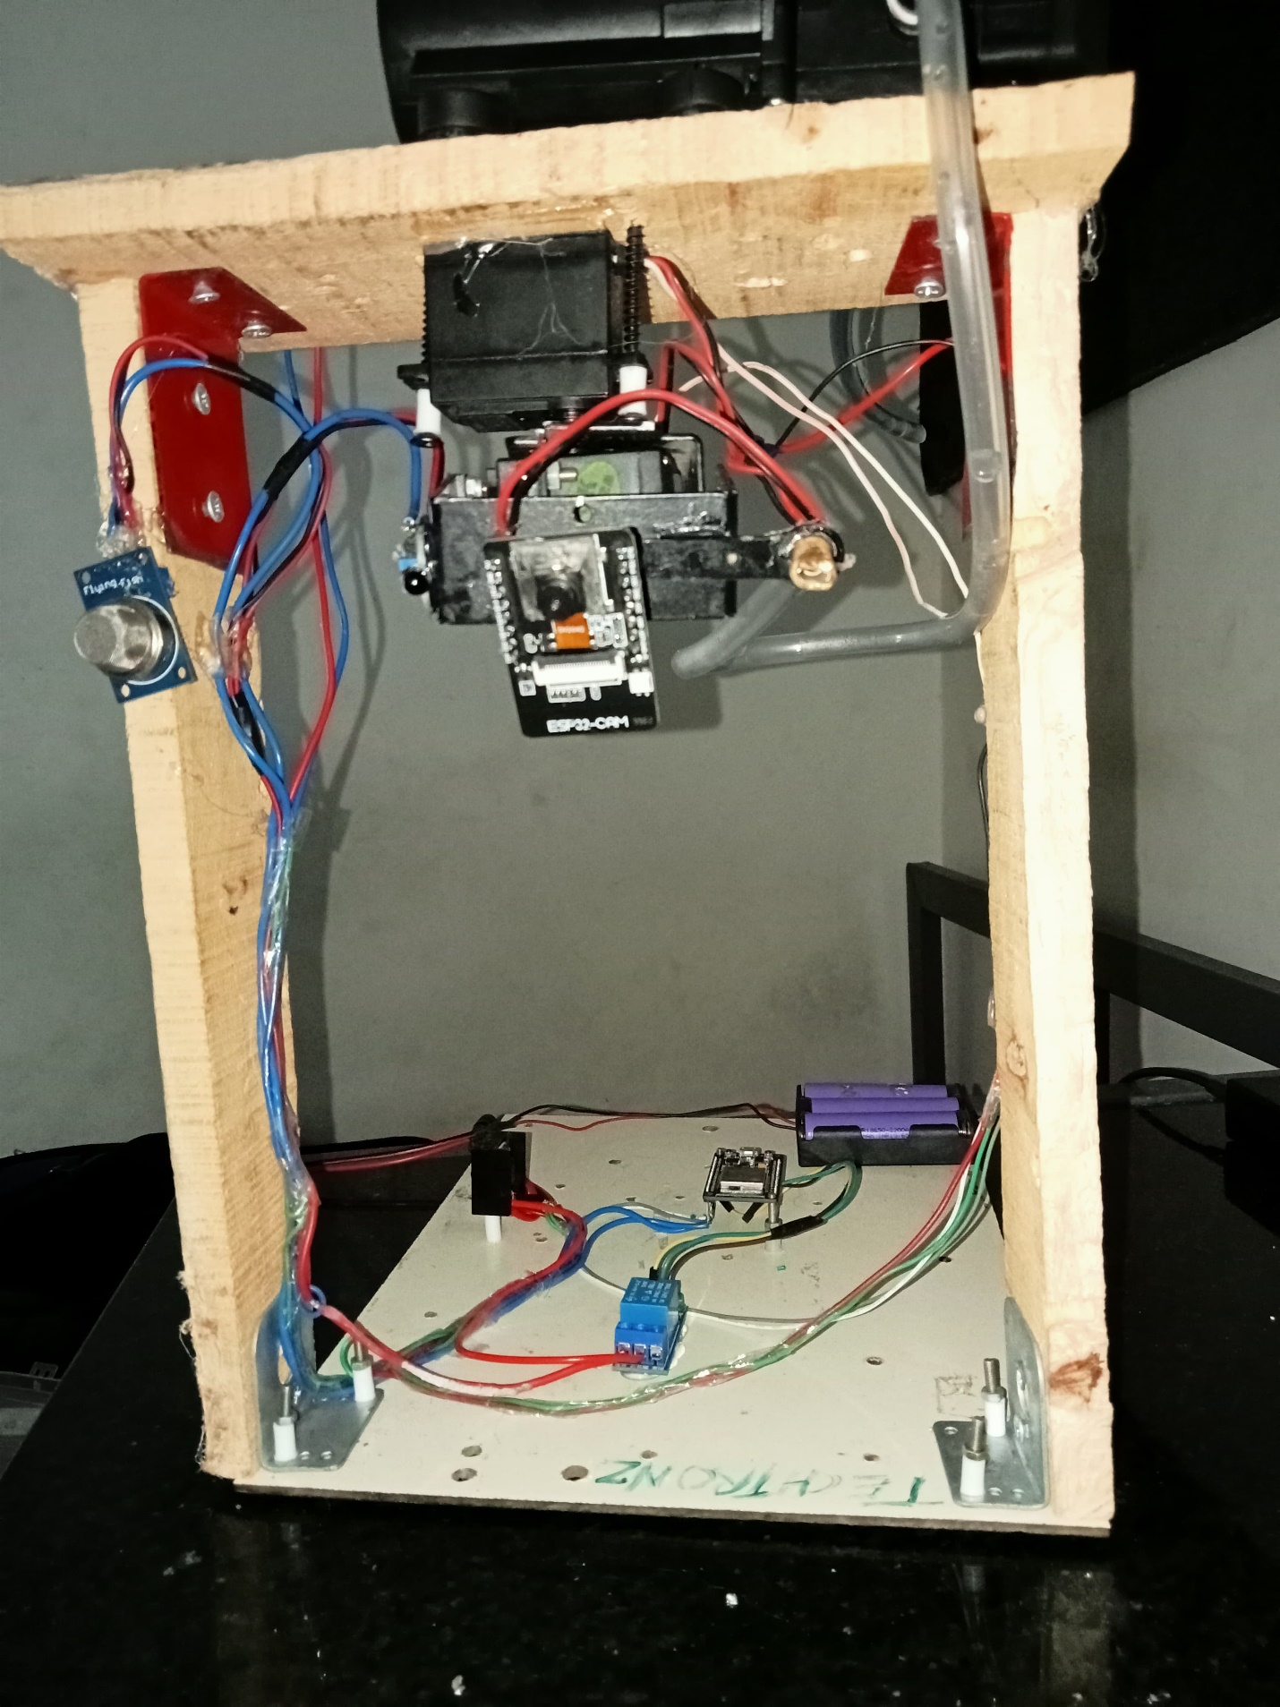

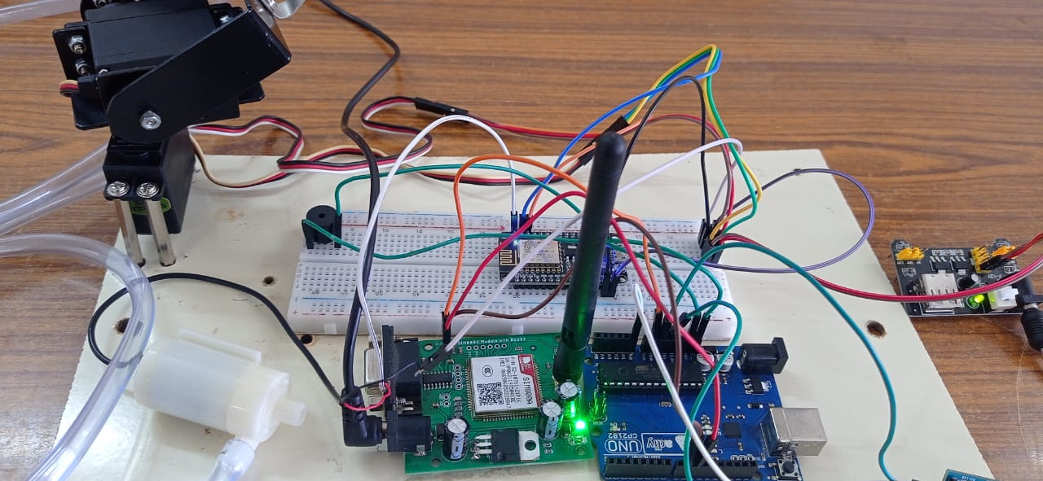

COMPONENTS IMAGES:

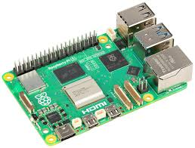 Raspberry Pi

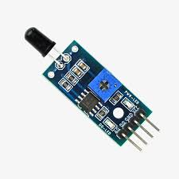 Flame Sensor

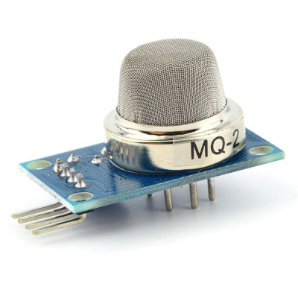Gas or Smoke Sensor

